**Project 4 - STOP Sign Detection For Blind Low-Vision Pedestrian (Also Implement Code For YIELD Sign Detection)**

**Name: Parshwa Rajyaguru**

**Section 1:**

**Android Studio running where you have opened up project file in "temp" directory.**

Version of Android SDK - 2.3

Minimum SDK Version - 21

Version of OpenCV - 3.1.0

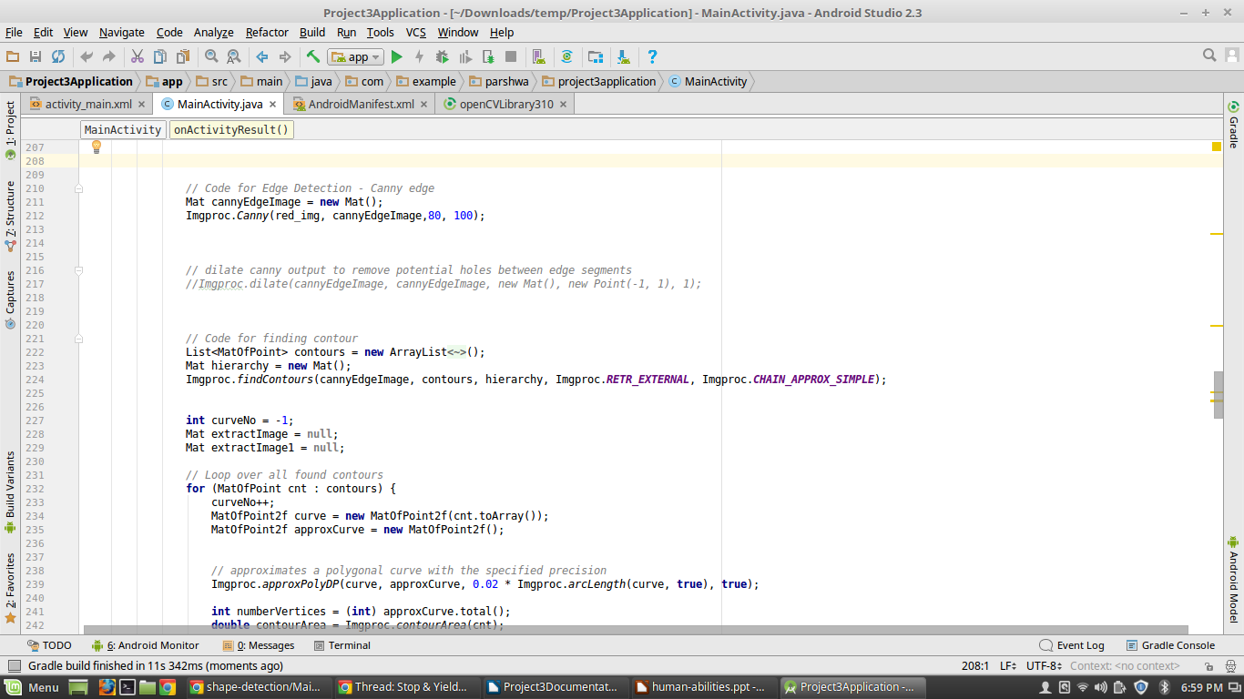

**Eclipse running the application - show screenshot of it running. If I must do something beyond simply hitting the "run" button, you need to give screenshots and step by step instructions.**

I am using Nougat AVD. I am running on Nexus 5 with API 25 for emulator and Nexus 5 (Android 6.0.1) with API 23 for physical device.

For downloaded and unzip code, do clean project from build menu and this code I use to install apk in android studio in its terminal window.

sudo adb install /home/dipen/software/OpenCV-android sdk/apk/OpenCV_3.1.0_Manager_3.10_x86.apk

And then run code.

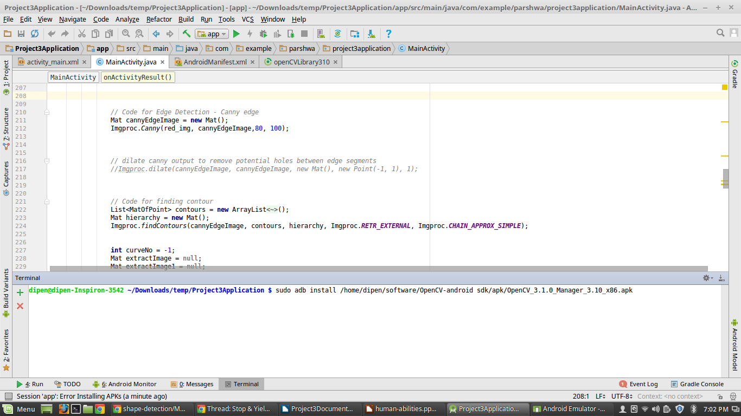

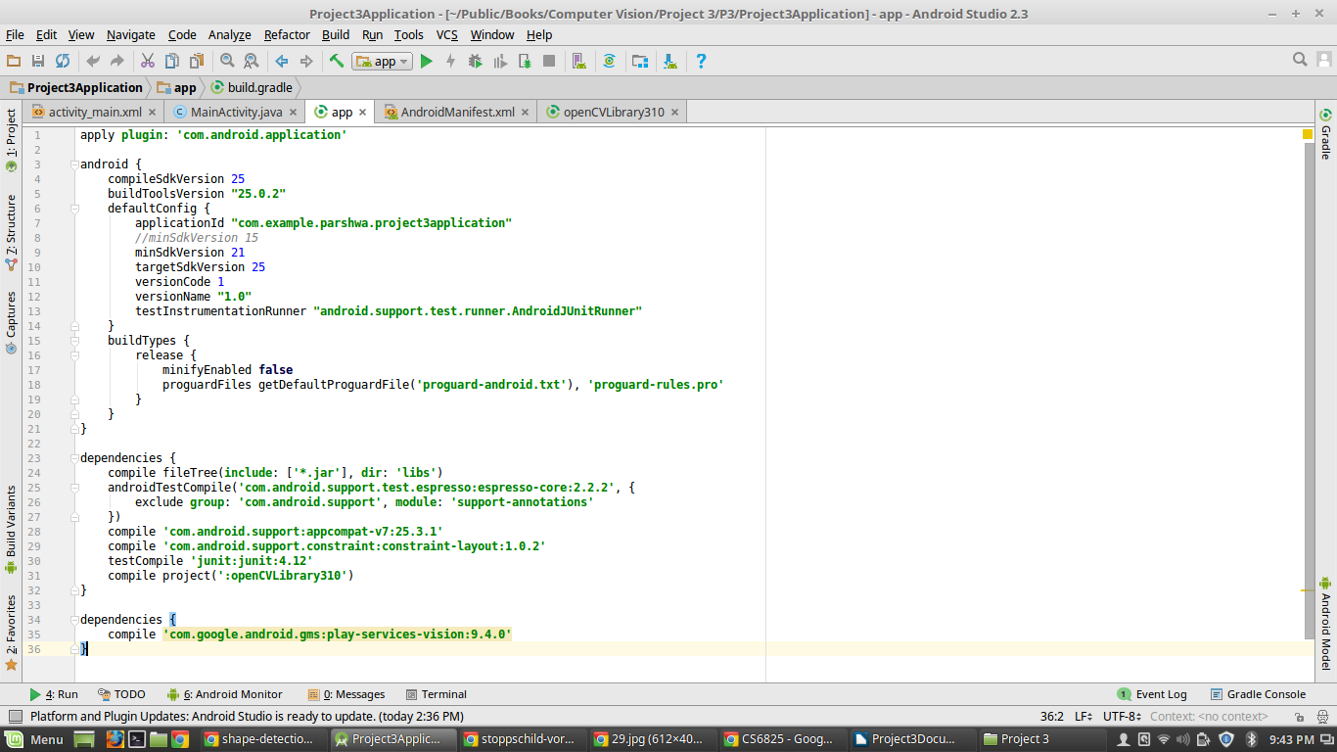

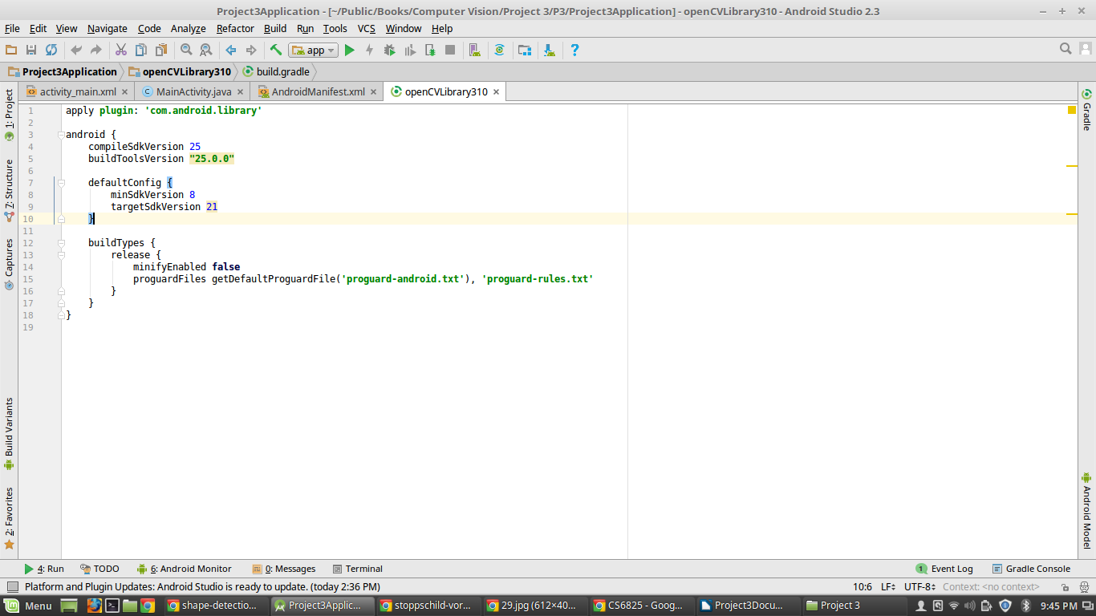

**Section 2: Code Description**

1. First, I took Bitmap image and convert it into Mat object.

Utils.bitmapToMat(photo, originalImage);

1. To filter out noise, I am using upscale and downscale.

I wrote code like,

Mat downscaled = **new** Mat();

Imgproc.pyrDown(originalImage, downscaled, **new** Size(originalImage.cols()/2, originalImage.rows()/2));

Imgproc.pyrUp(downscaled, originalImage, originalImage.size());

1. Then I Mat object image – RGB color space into HSV space.

I wrote code like,

Imgproc.cvtColor(originalImage, hsvImage, **COLOR_RGB2HSV**);

1. Color Threshold Step:

Then, Set red color range which only identify red color from image. Resulting image is red color thresholding image.

For this, I am using Core’s ‘inRange’ method to implement red color thresholding on upper and lower range.

Then, I do Bitwise AND operation on both lower and upper range. For that, I am using ‘bitwise_or’ method which is Core’s method.

I wrote code like,

Core.bitwise_or(lower_red, upper_red, red_img);

1. Edge detector:

I use Canny Edge Algorithm for edge detection.

I wrote code like,

Imgproc.Canny(red_img, cannyEdgeImage,80, 100);

1. To remove potential holes between edge segments from canny output, I do dilate on resulting image after Canny edge detector.

I wrote code like,

Imgproc.dilate(cannyEdgeImage, cannyEdgeImage, **new** Mat(), **new** Point(-1, 1), 1);

1. Contour Finding step:

For this, I used findContours method, which detected all possible shapes from image.

I wrote code like,

Imgproc.findContours(cannyEdgeImage, contours, hierarchy,Imgproc.**RETR_EXTERNAL**, Imgproc.**CHAIN_APPROX_SIMPLE**);

Then, I loop through all detected contours and eliminate smaller contours.

1. Yield Sign Detection:

If contour has 3 vertexes, then may be it is possibility of yield sign.

Then I find bounding box around detected contour region. For finding points, I wrote code like,

MatOfPoint points = **new** MatOfPoint(approxCurve.toArray());

// Get bounding rect of contour

Rect rect = Imgproc.boundingRect(points);

1. Yield Sign Recognition:

Through OCR, I check whether there is “YIELD” characters inside bounding box or not.

For OCR, I am using Mobile Vision Android API service.

1. Stop Sign Detection:

It first check whether there is 8 vertexes found or not. If it found, then it calculate angle of each vertexes and store minimum and maximum vertex. Then it check whether mincos and maxcos are in range or not. If it is, then may be it is possibility of Stop sign.

Then I find bounding box around detected contour region. For finding points, I wrote code like,

MatOfPoint points = **new** MatOfPoint(approxCurve.toArray());

// Get bounding rect of contour

Rect rect = Imgproc.boundingRect(points);

1. Stop Sign Recognition:

Through OCR, I check whether there is “YIELD” characters inside bounding box or not.

For OCR, I am using Mobile Vision Android API service.

1. Convert resulting Mat object image into Bitmap object.

Code like,

Utils.matToBitmap(result, bmp);

1. For final result image, if there is Stop or Yield Sign detected, then my app draw outline frame around contour and detected bounding box.

Then it alert user via audio speech about detected signs. For this, I am using android TextToSpeech class.

Then I am also showing result to user via Text message. For this, I am using Toast’s makeText method.

For all of this, I wrote code like,

**engine**.speak(**"Yield sign ahead"**, TextToSpeech.**QUEUE_FLUSH**, **null**, **null**);

Imgproc.rectangle(originalImage, **new** Point(rect.**x**, rect.**y**), **new** Point(rect.**x** + rect.**width**, rect.**y** + rect.**height**), **new** Scalar(0, 255, 0), 1);

Imgproc.drawContours ( originalImage,contours,curveNo,**new** Scalar(0, 255, 0),1);

Toast.makeText(**this**, **"Yield Sign"**, Toast.**LENGTH_LONG**).show();

**Section 3: Testing**

**Section 3.1: starting application**  
  
**Screenshot 3.1a: showing icon and resulting starting GUI.**

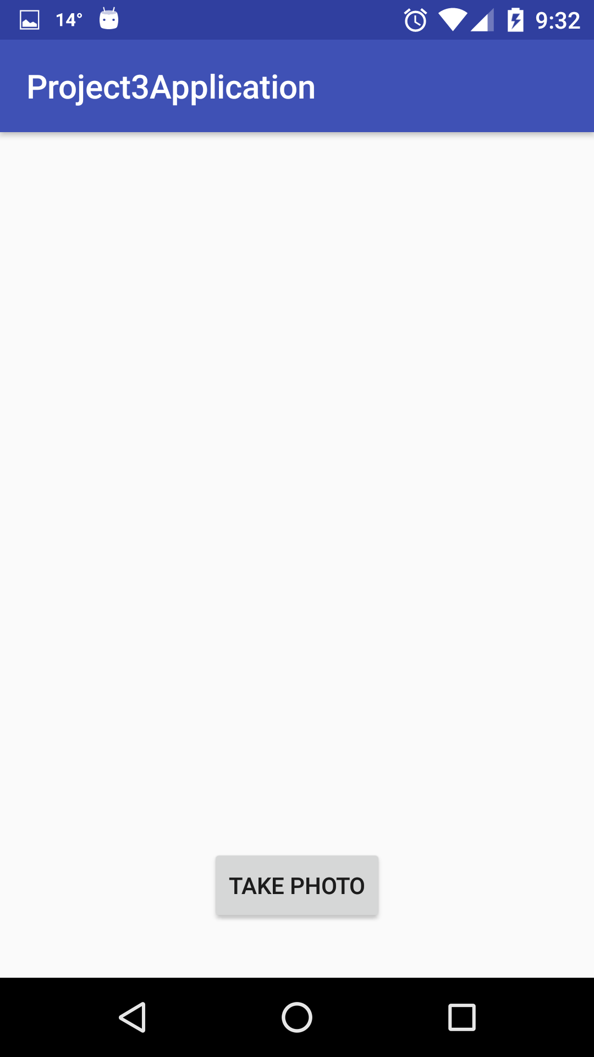

**Screenshot 3.1b: When ‘TAKE PHOTO’ button click it open camera and you can capture image as input.**

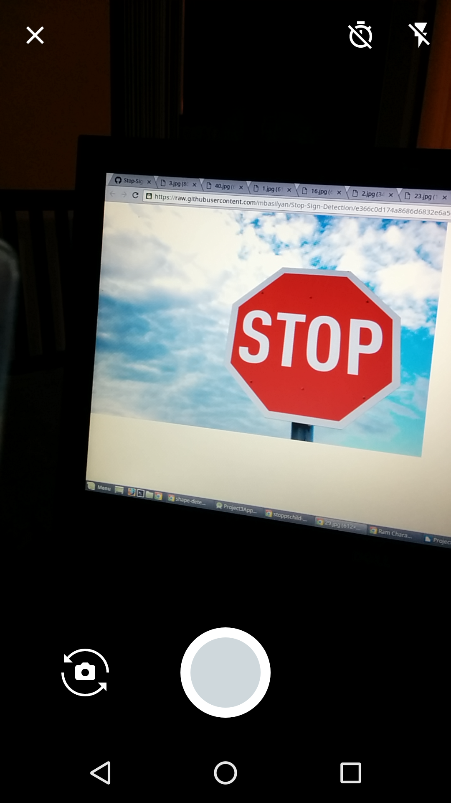

And resulting image show in imageView on my App GUI.

**Section 3.2: Testing Images Result**

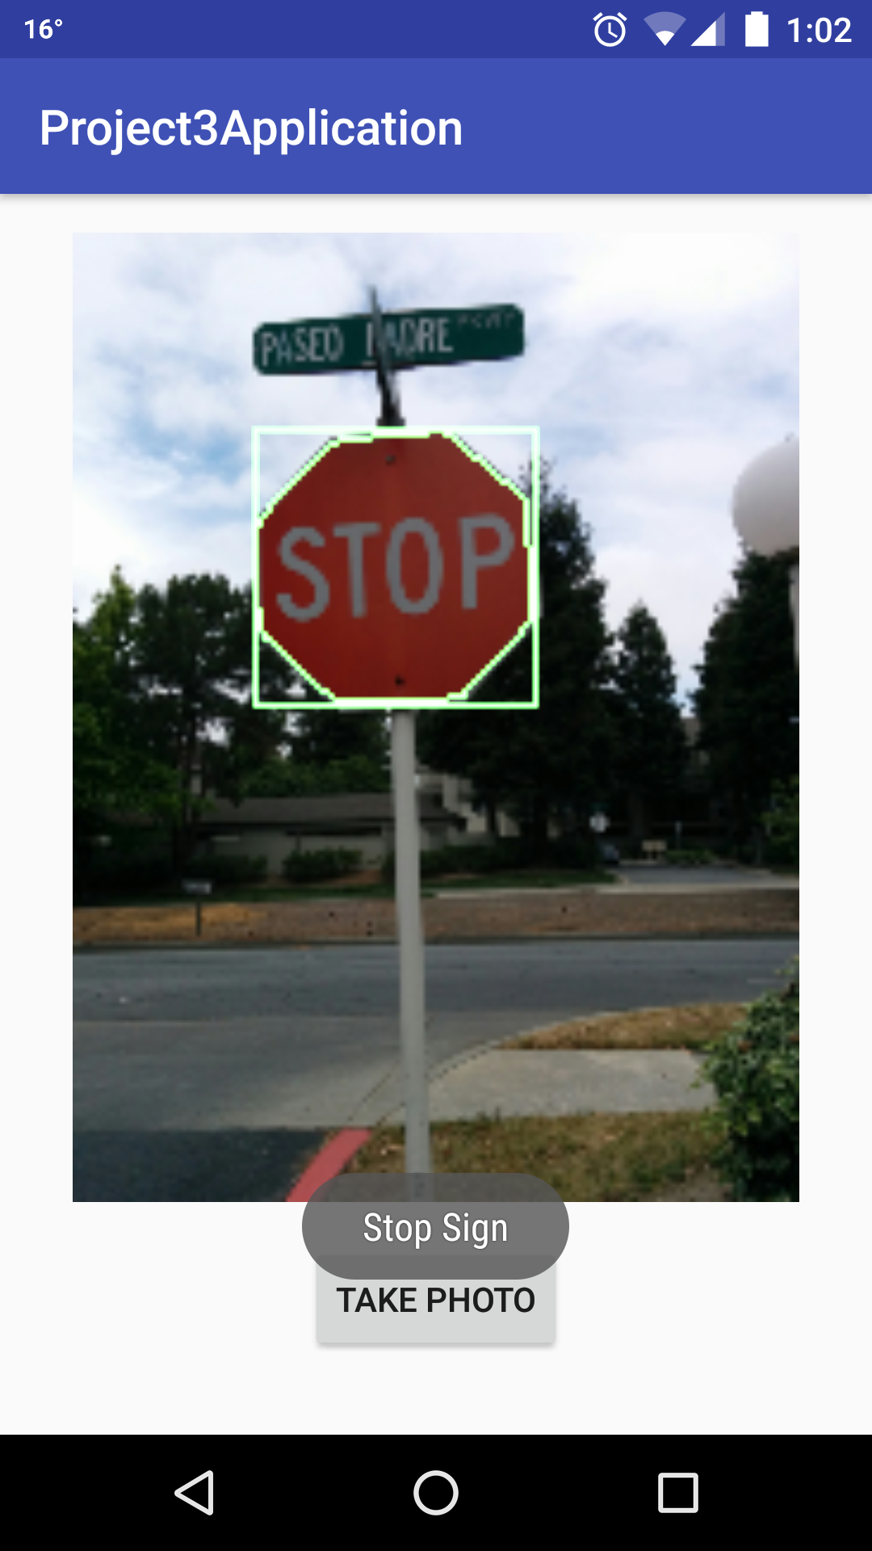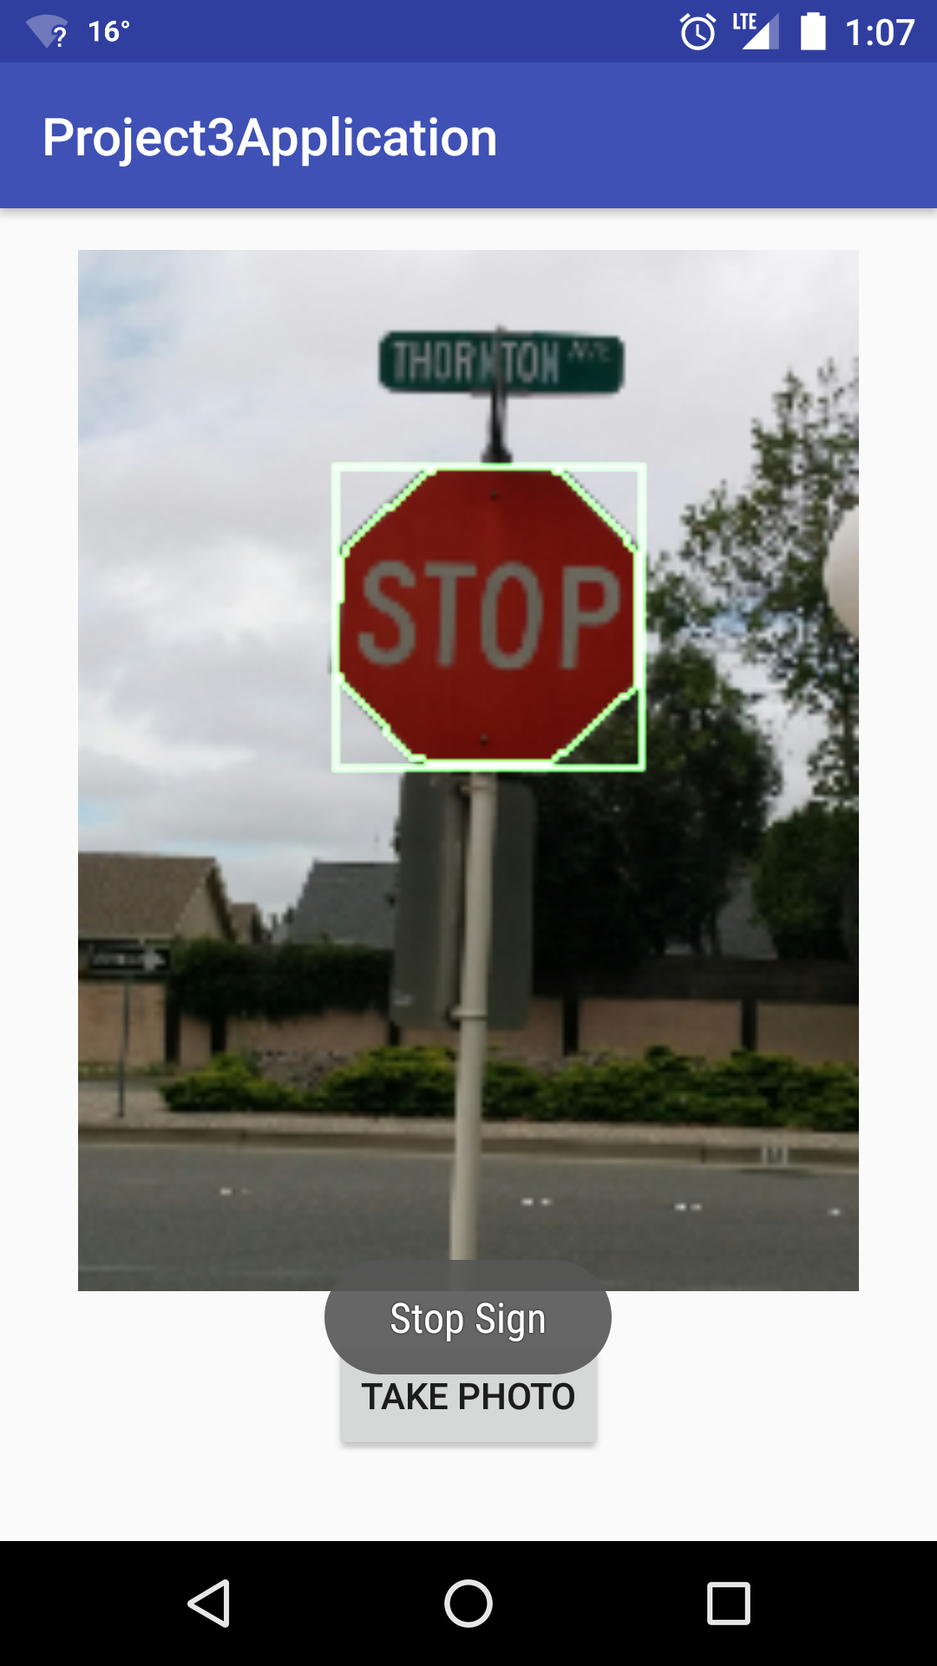

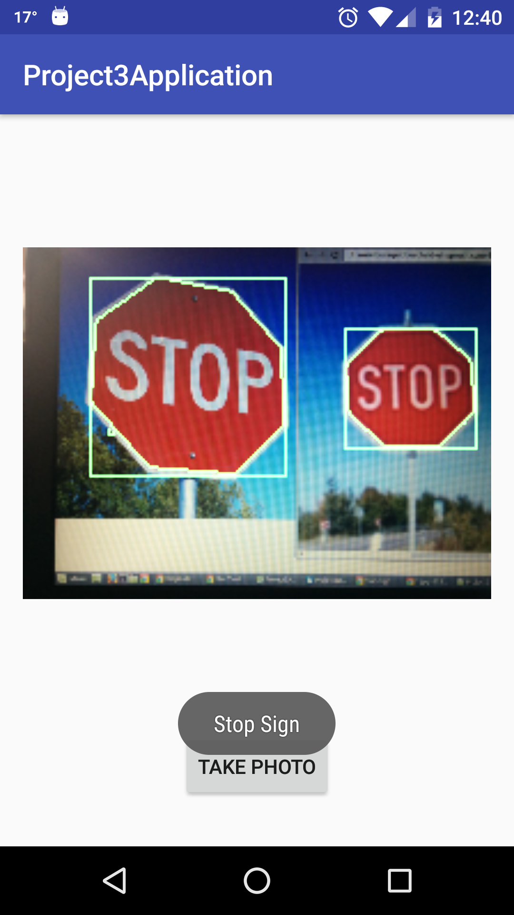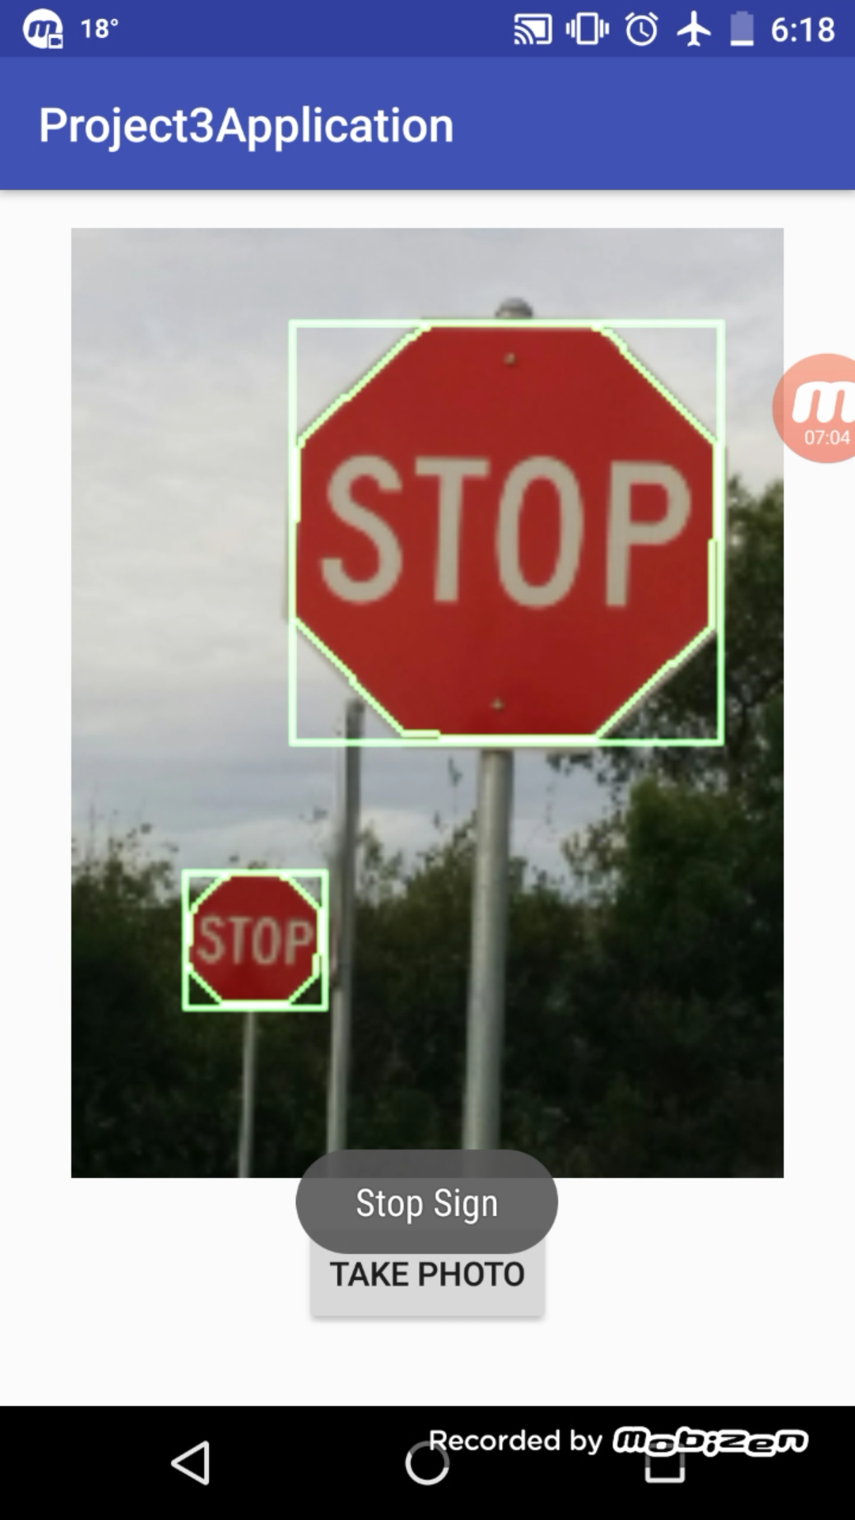

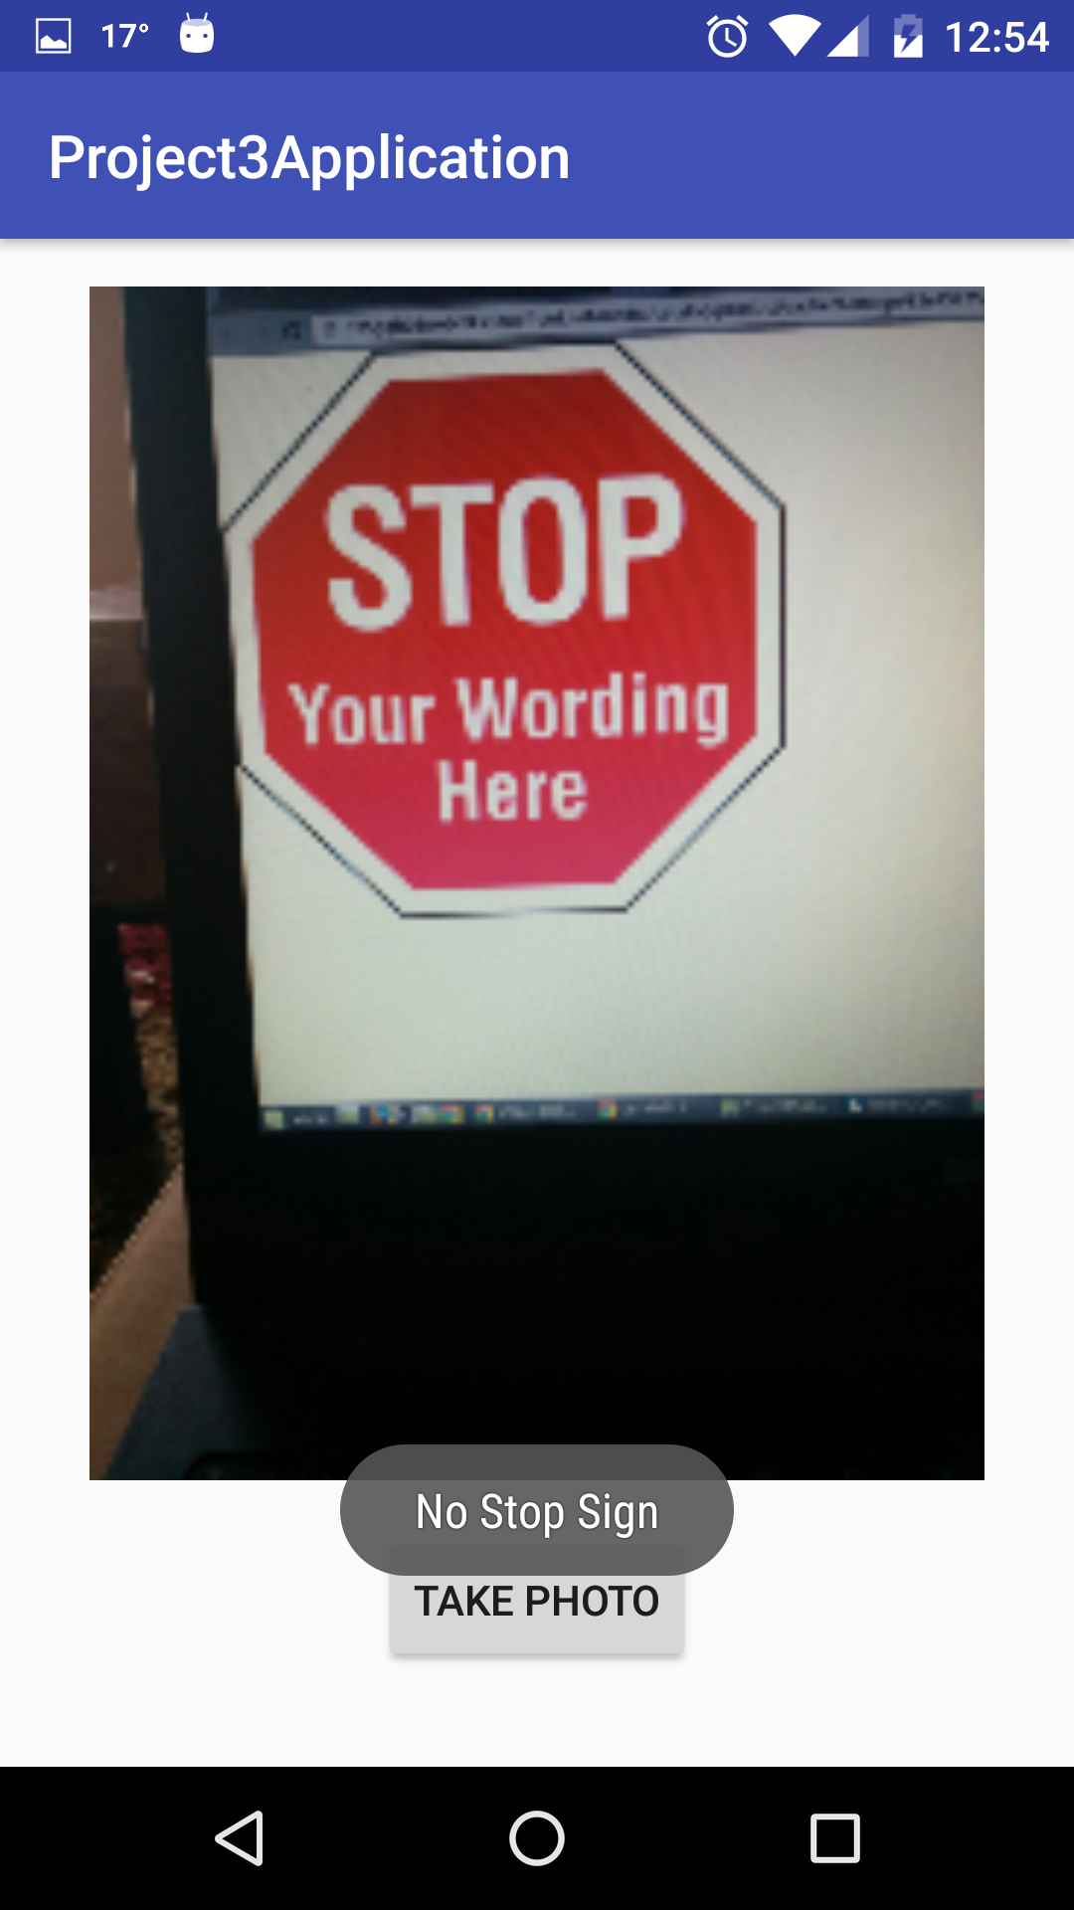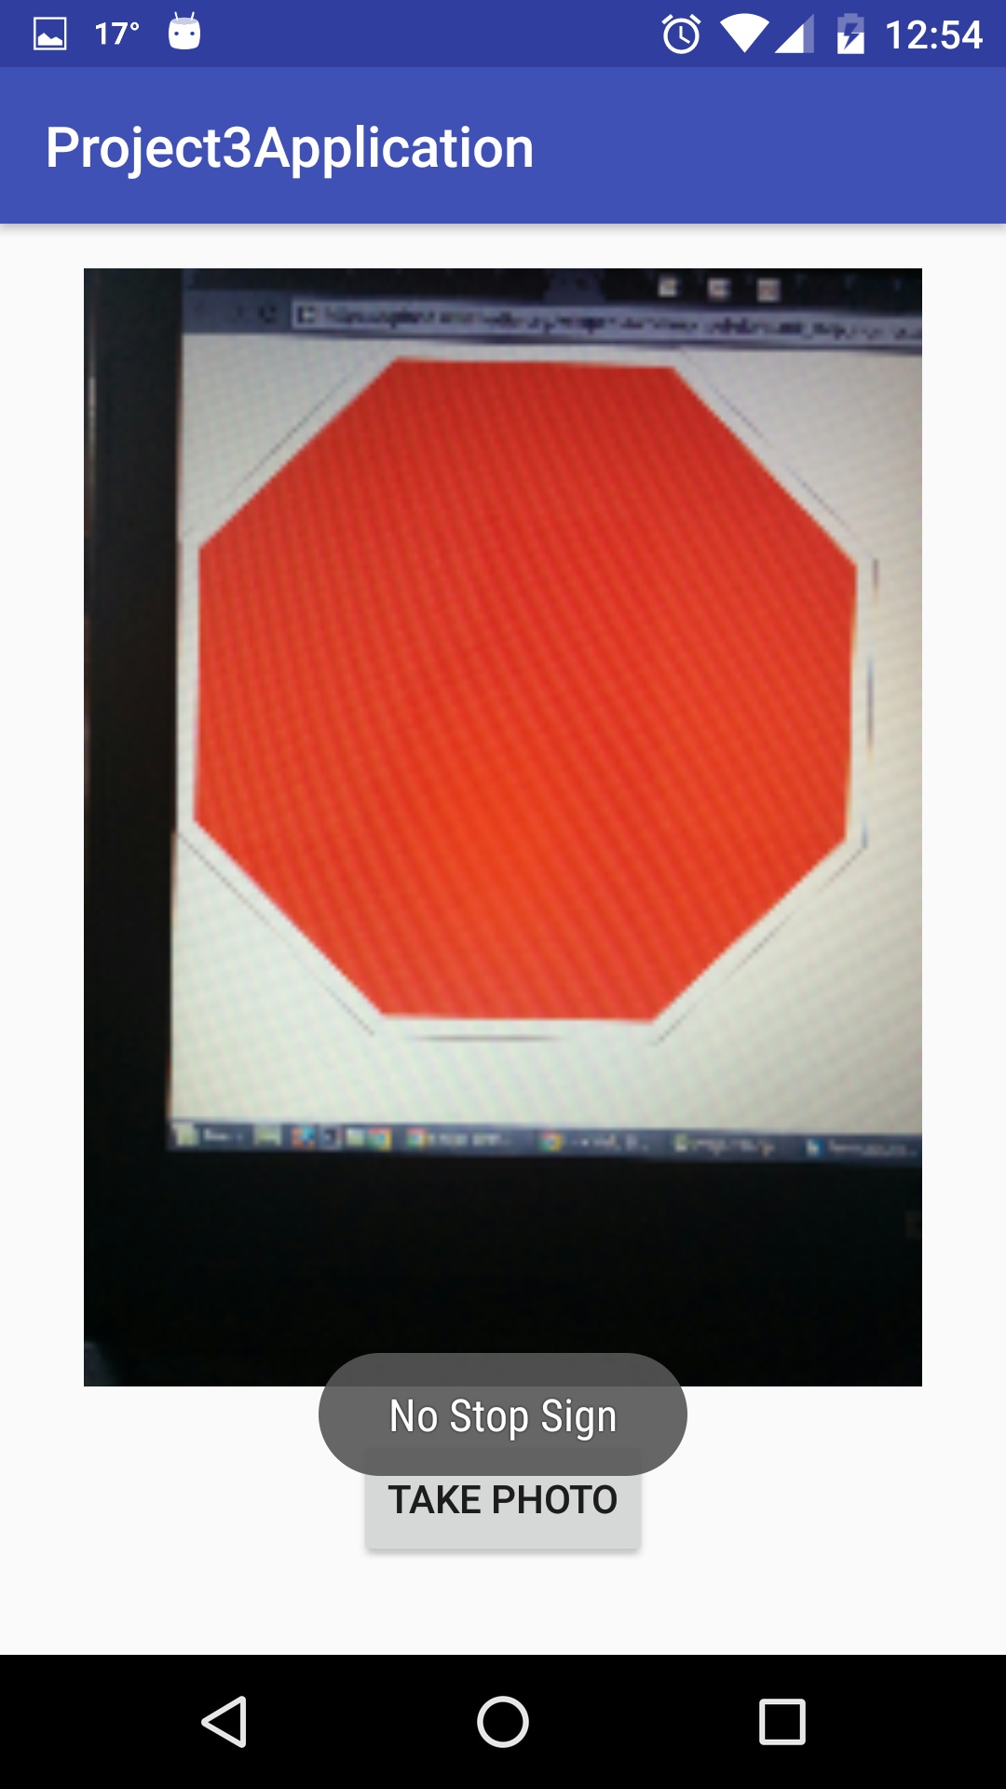

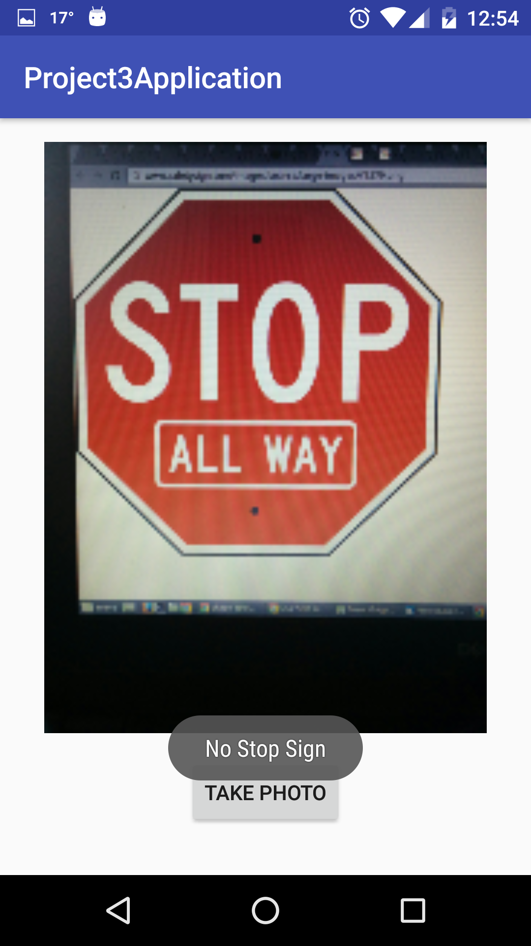

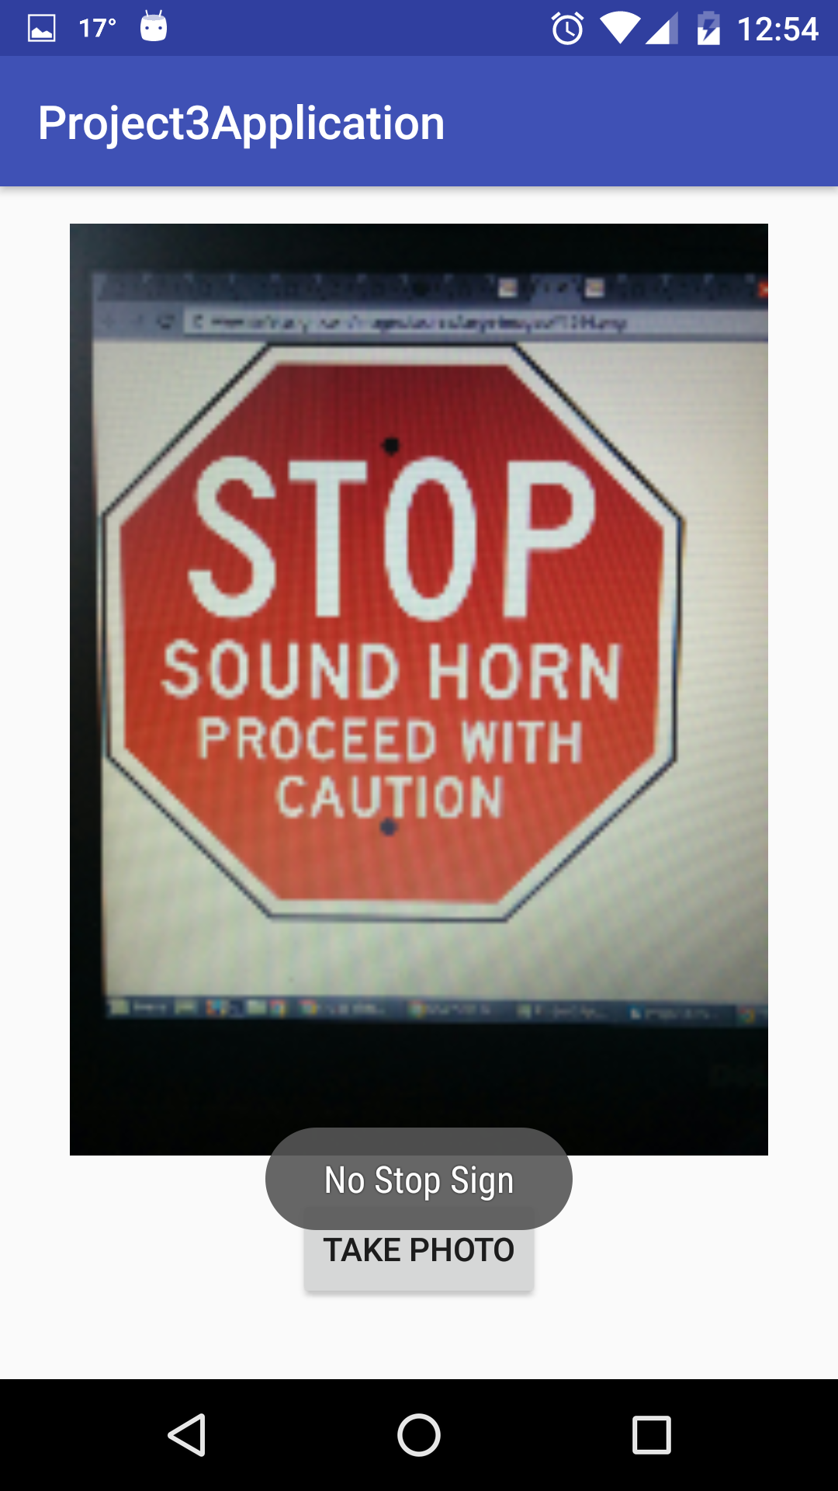

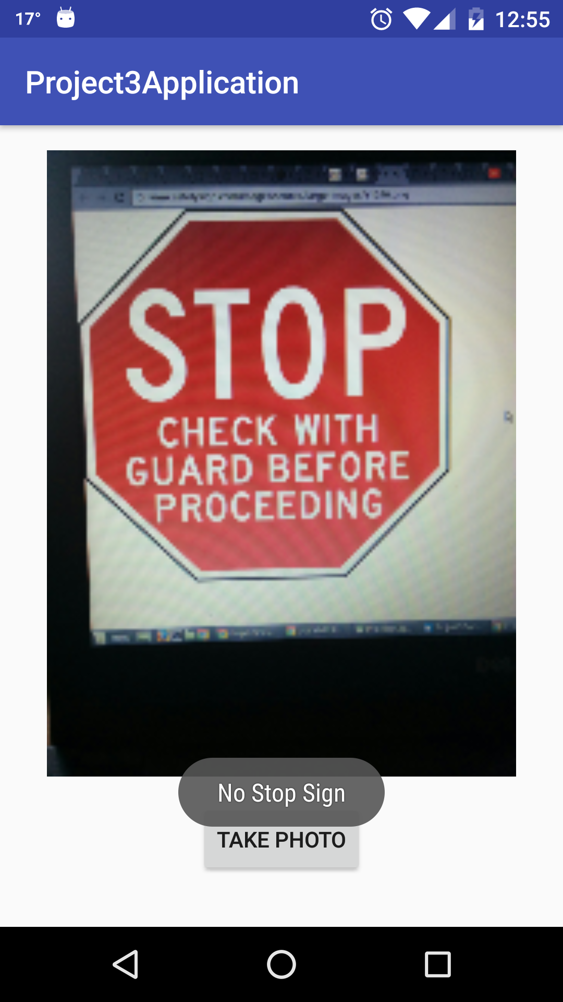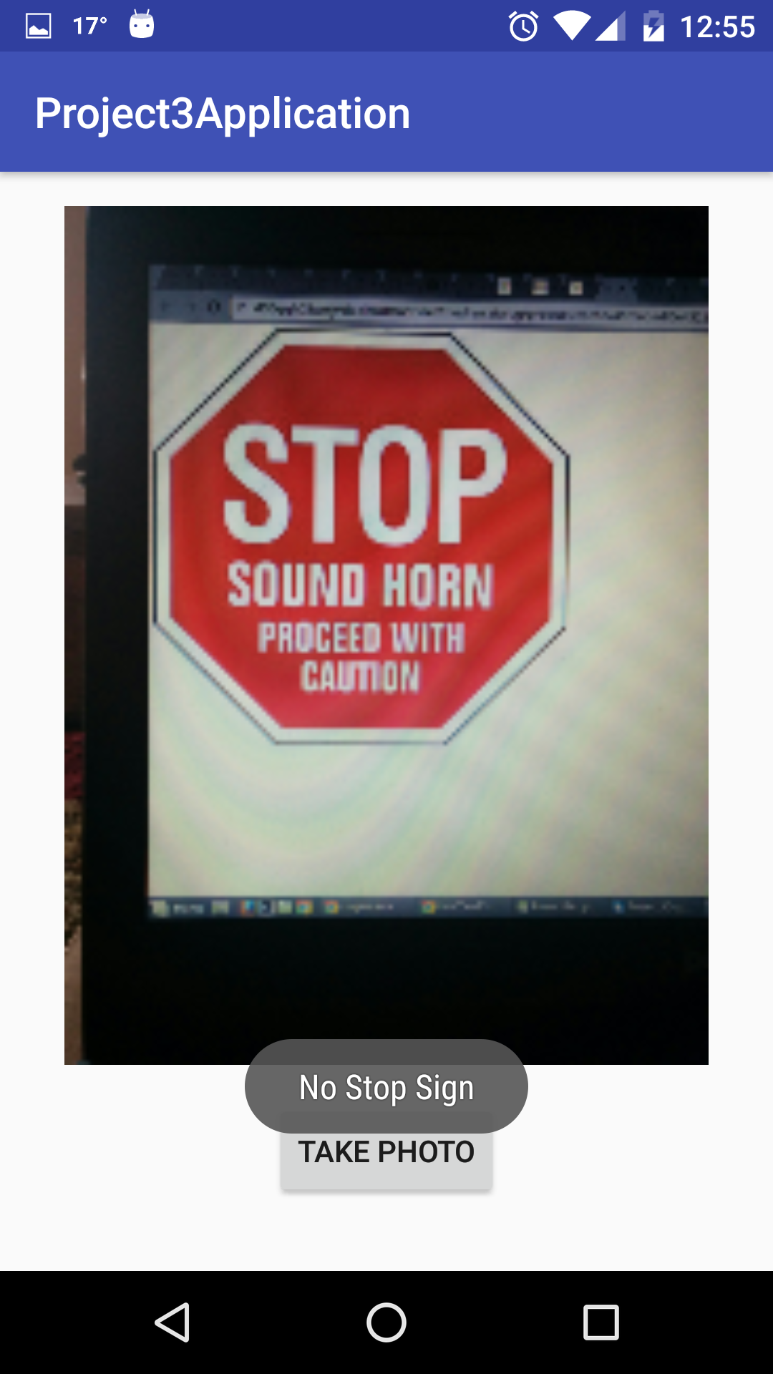

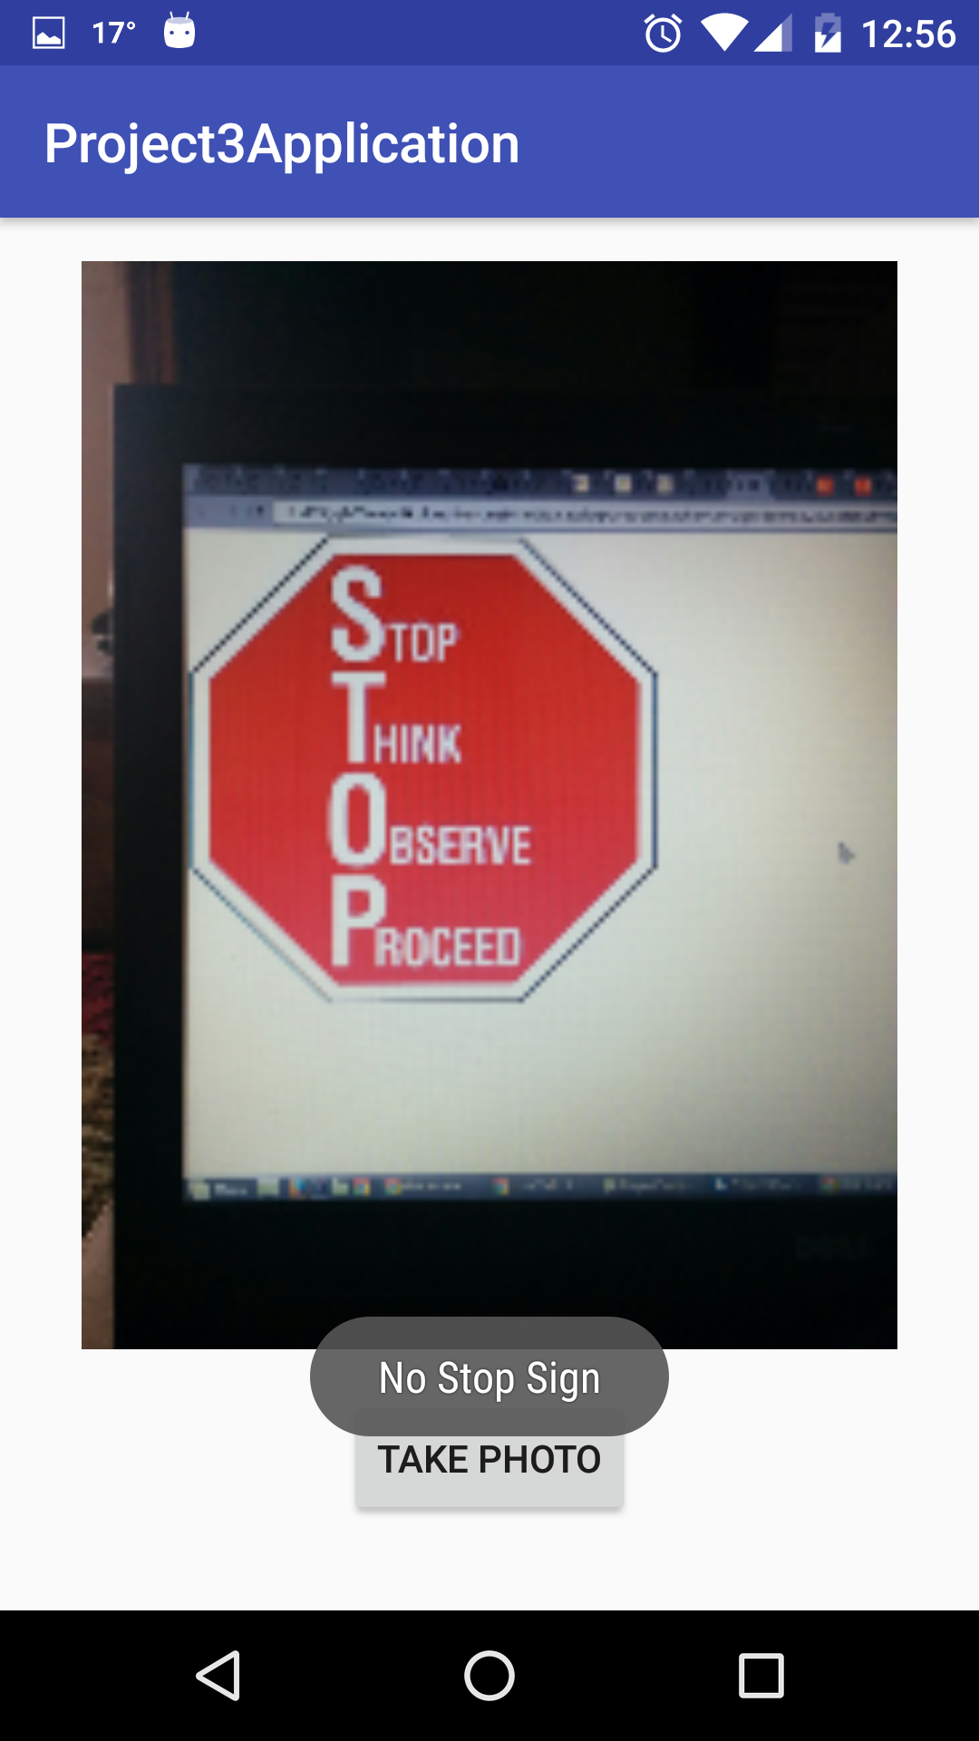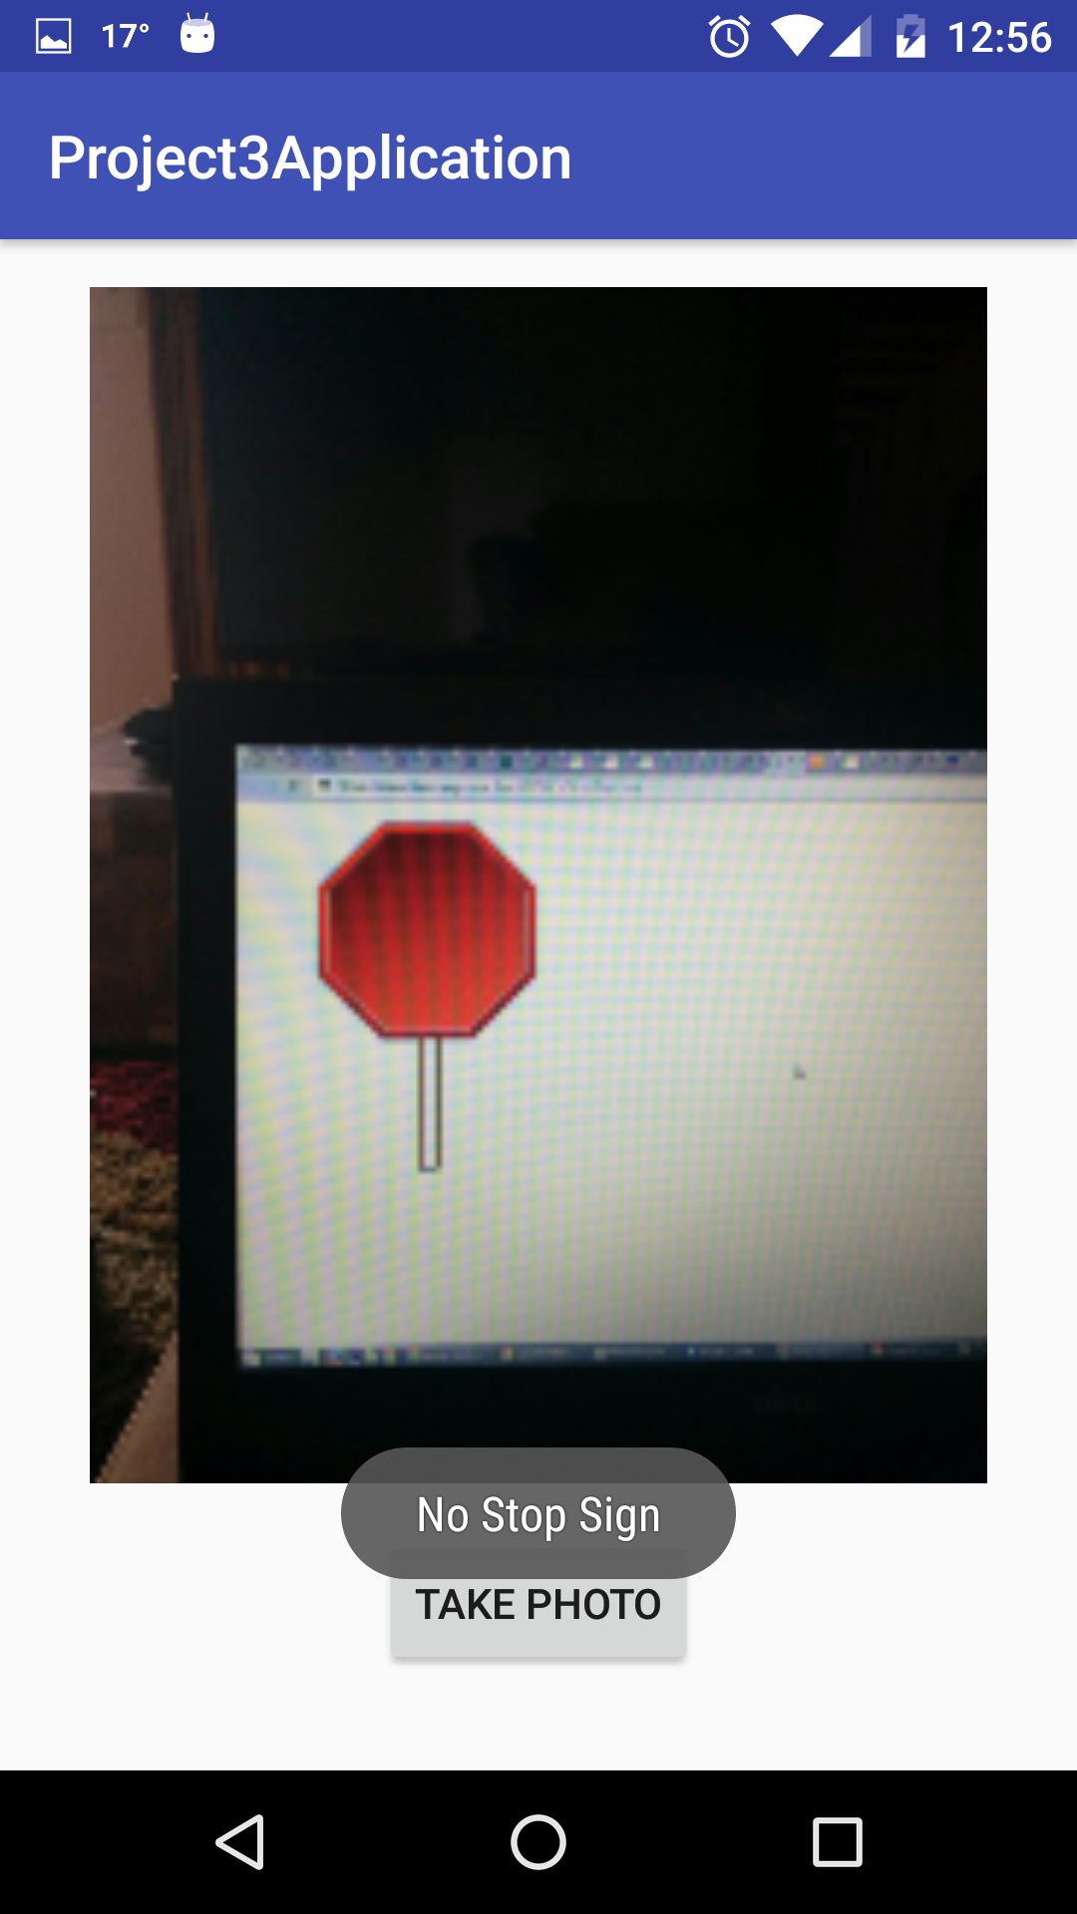

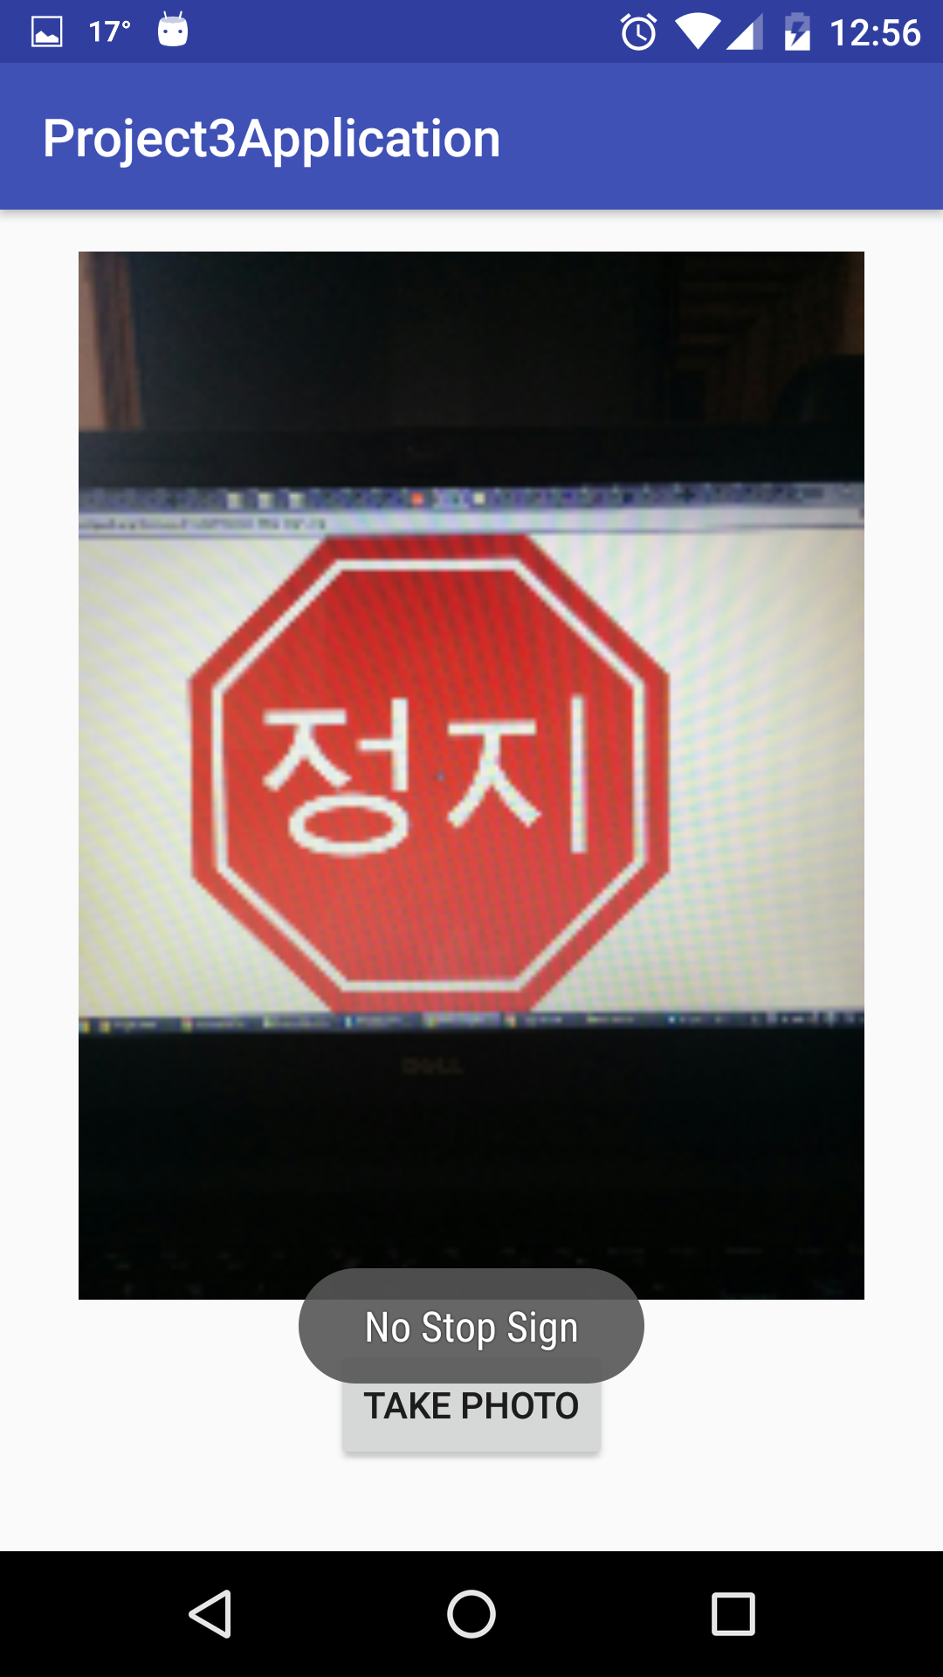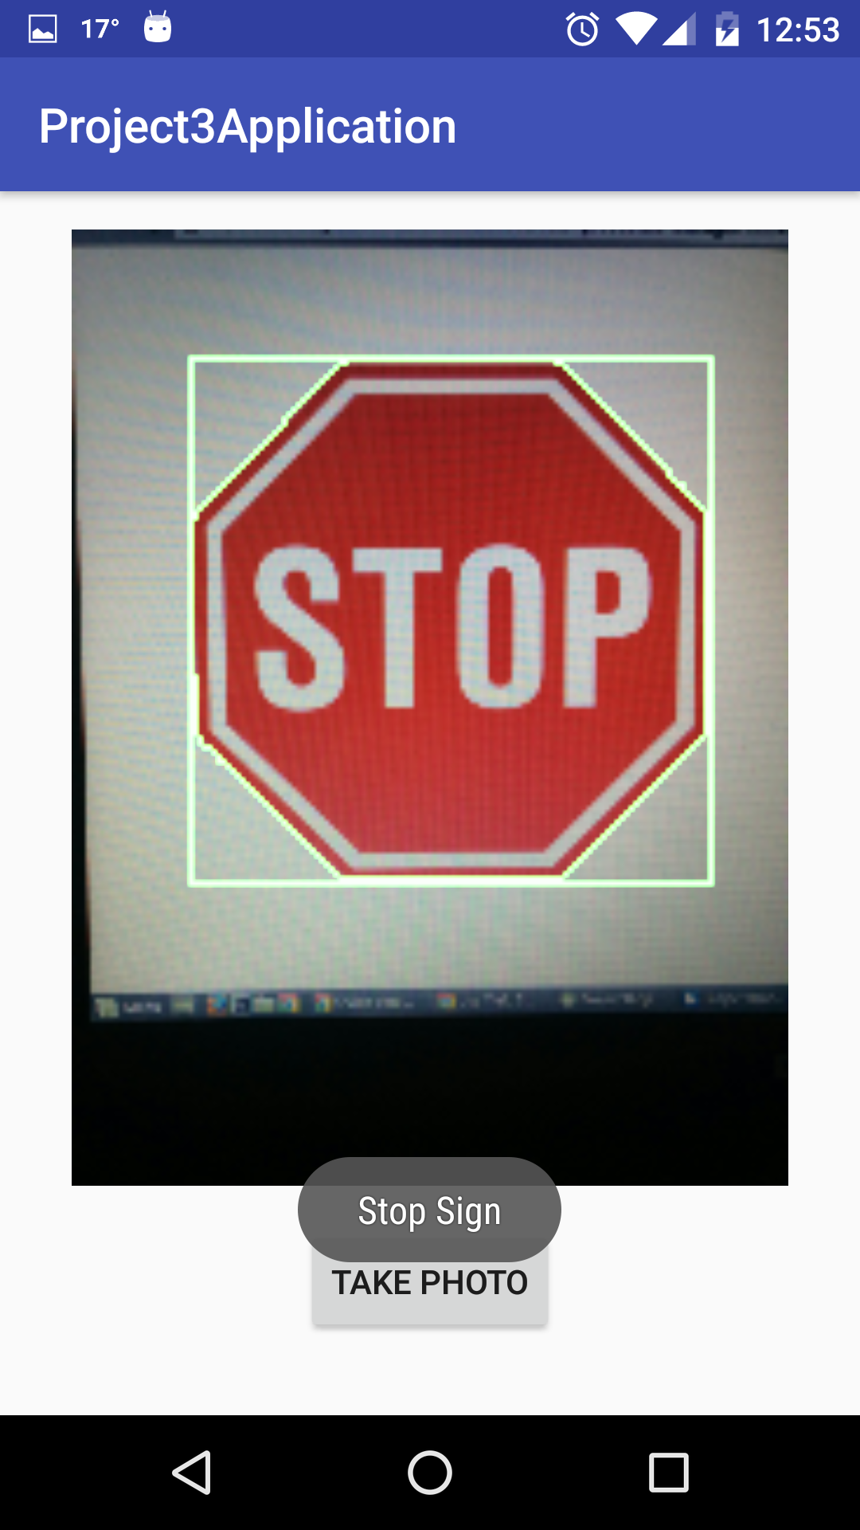

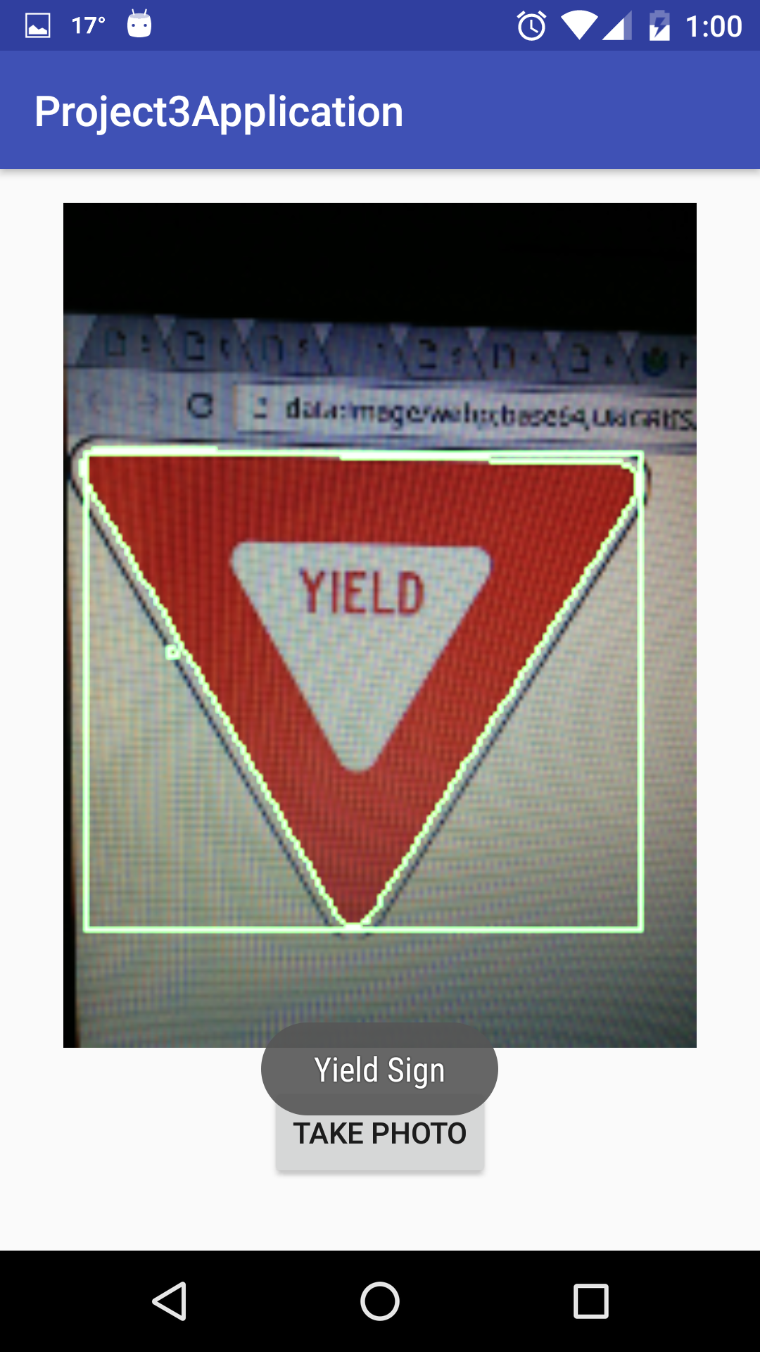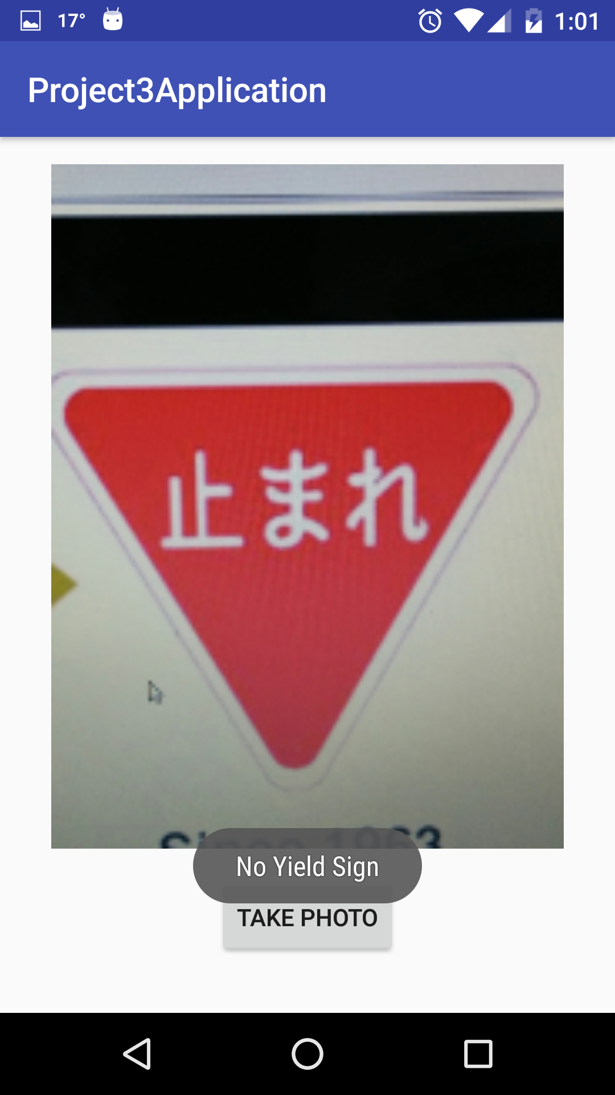

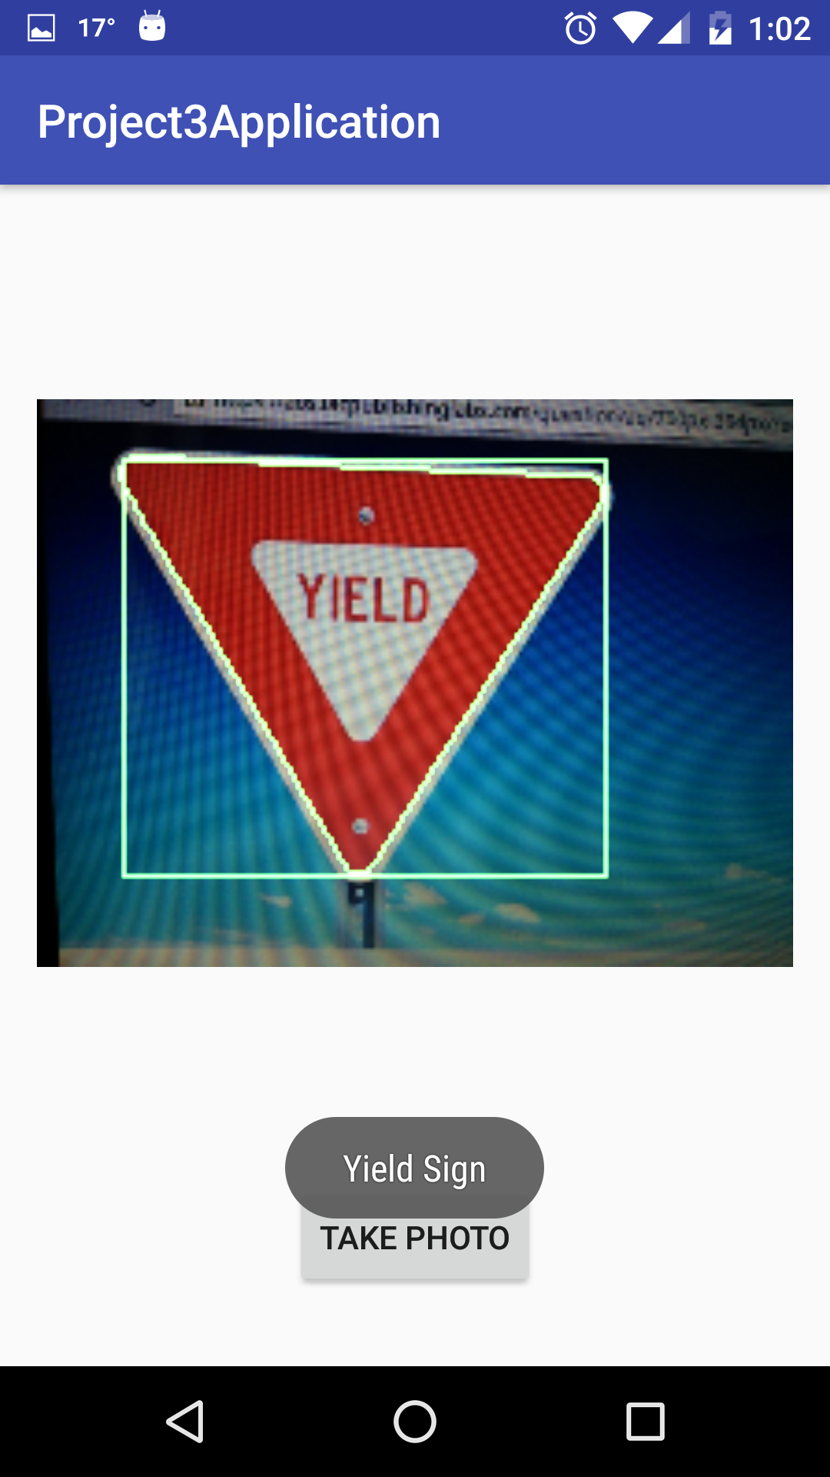

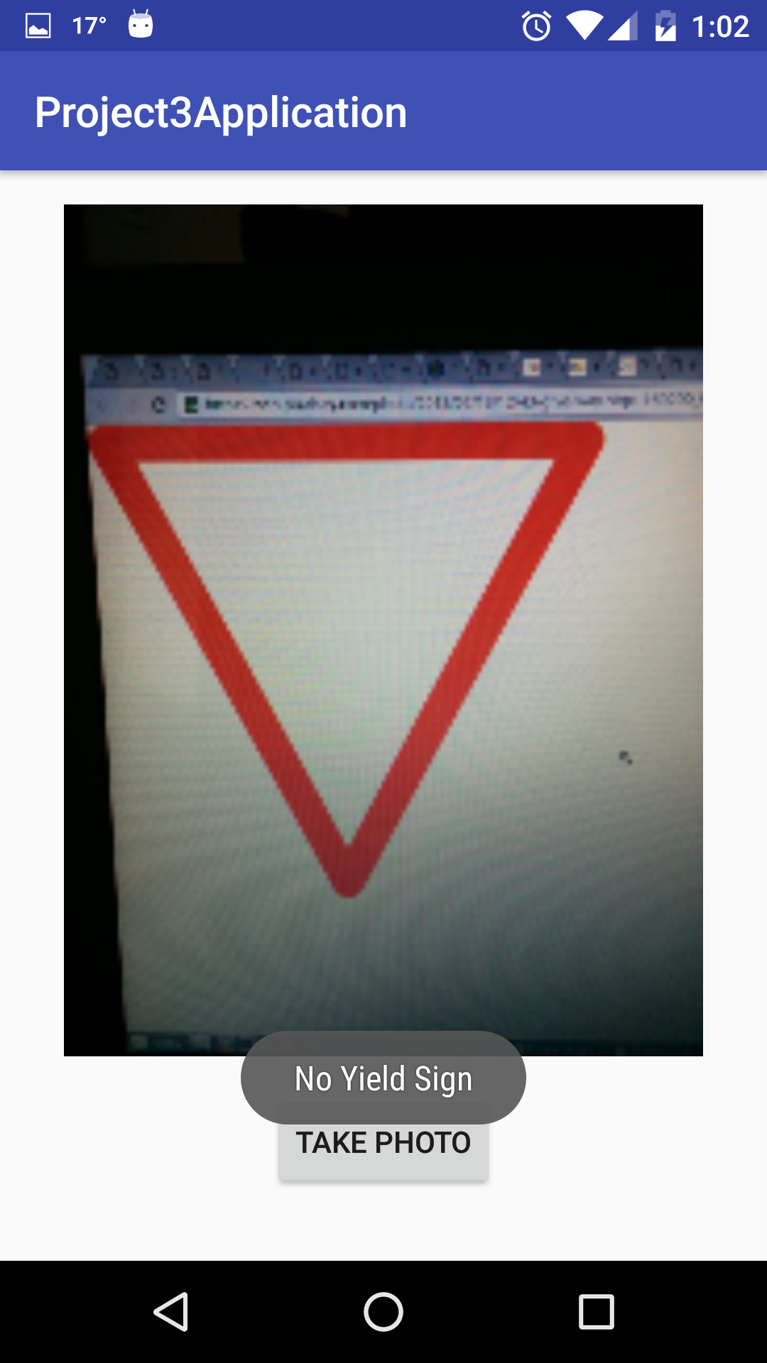

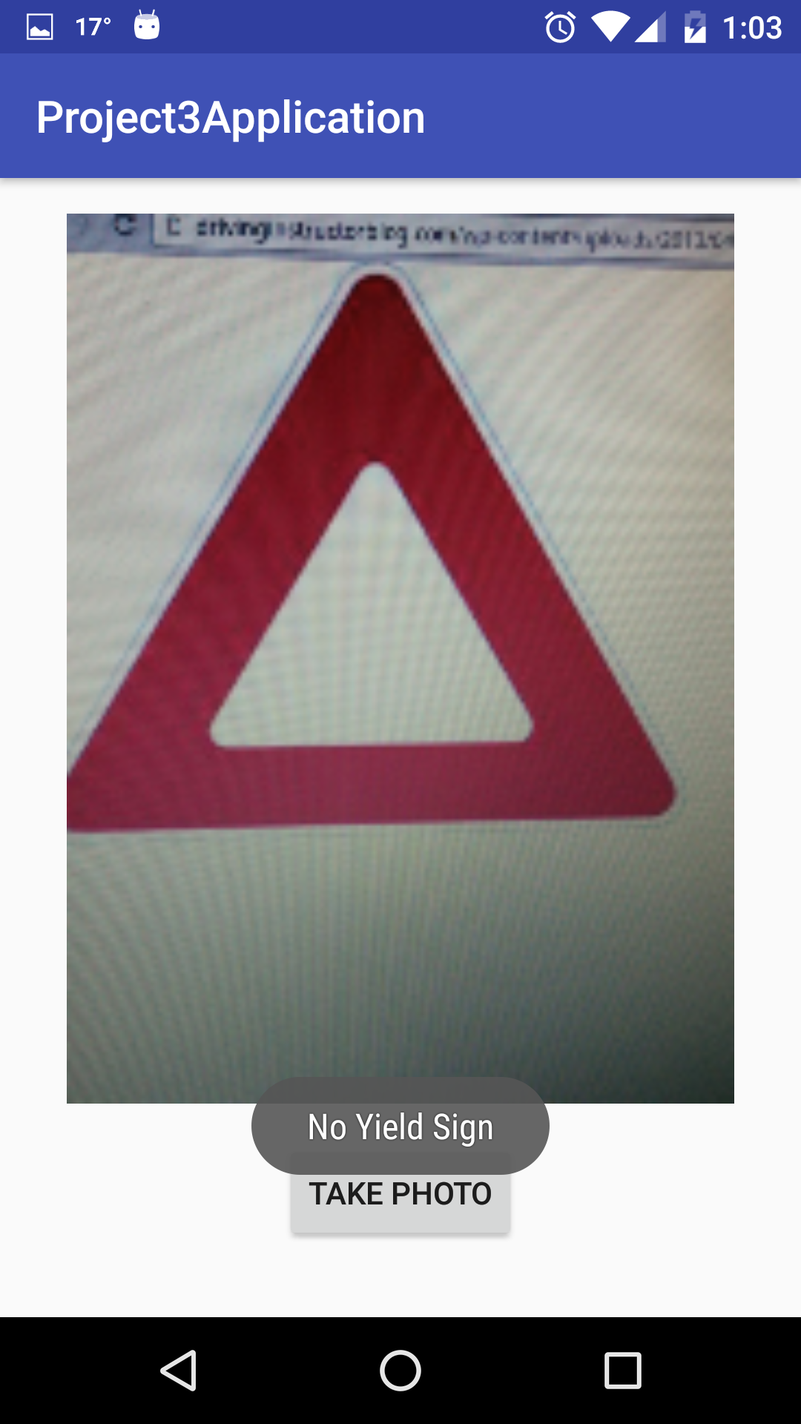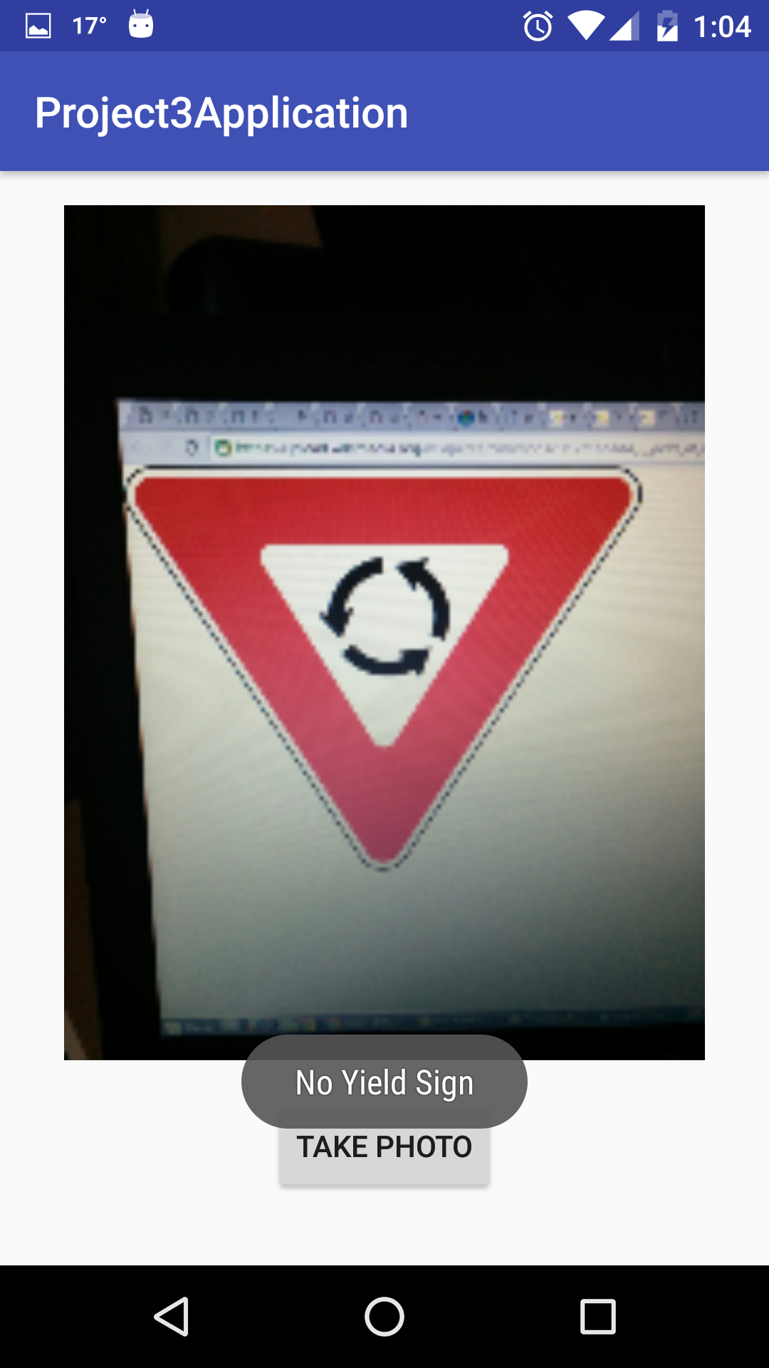

**Section 4: Comments**

My code is working on following conditions:

* Good lighting on stop sign board.
* Sign board doesn’t covered with shadow, tree and its characters should not be cover by some obstacles, not erase.
* Sign board should not be covered by snow or any other things.
* Camera should be within +/-10 degree range from traffic sign board. You must zoom in little and you distance is around 5-10m.
* No glare and bulb light or sun rays hits in such a way that it cover traffic sign board.
* Traffic sign board should not be curved or tilt.
* My app doesn’t work if image is more rotated and image’s more side view .
* For yield sign, My app work if you take picture as zoom in as while doing OCR, it didn’t get all characters properly.

Sometimes OCR didn’t get ‘I’ and ‘L’ as both are very thin character. So you must zoom in and take proper image of yield sign. Then only it detect yield traffic sign.

* My app doesn’t work in night and evening as there is less light on traffic sign and traffic sign shown in more black shade and less red color identify.

**Section 5 : YOUTUBE URL LINKS:**

**Link1:**

<https://www.youtube.com/watch?v=goHAkwhob48&feature=youtu.be>

<https://www.youtube.com/watch?v=goHAkwhob48>

**Link2:**

<https://www.youtube.com/watch?v=yC-W85jZ6uY>